***Expenditure Data Analysis***

***Wireframe Documentation***

HomePage

As per the problem statement , we have divided analysis into Two section:

1. Dashboard 1 : Sales Amount , Profit and Growth

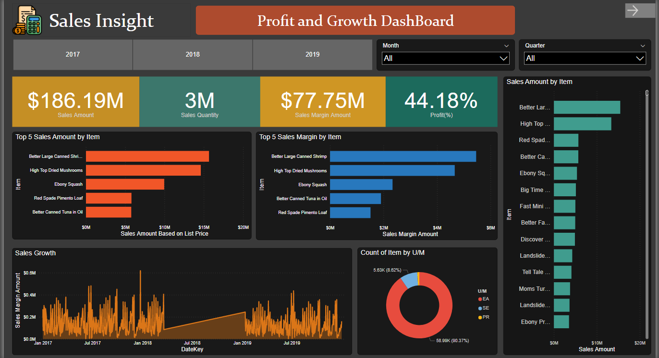

* Top 5 Sales Amount by item

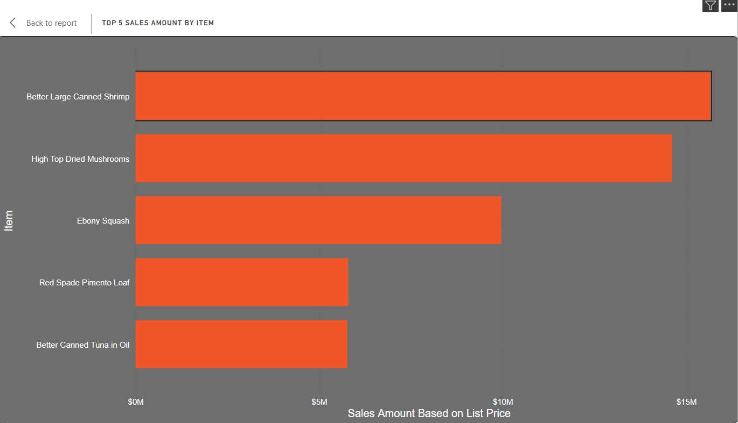

* Top 5 Sales Margin by item

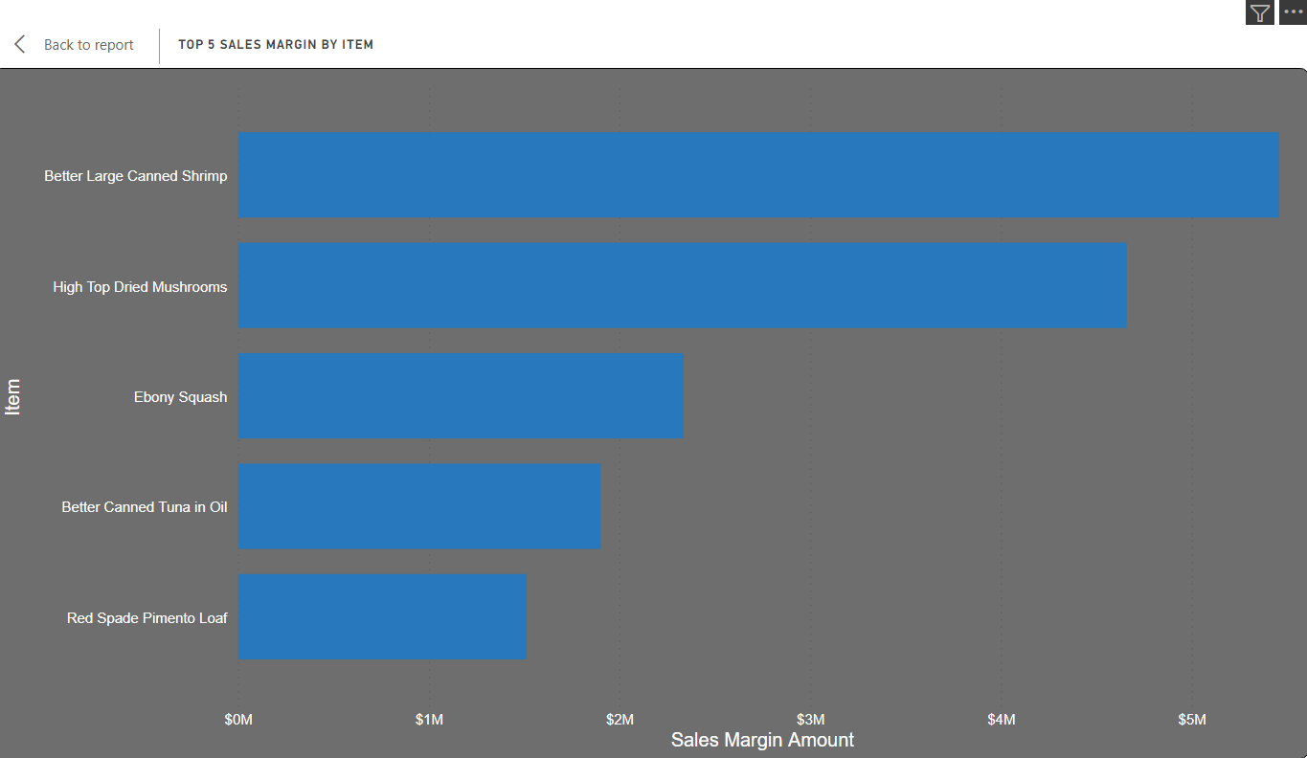

* Overall Sales Growth of Company

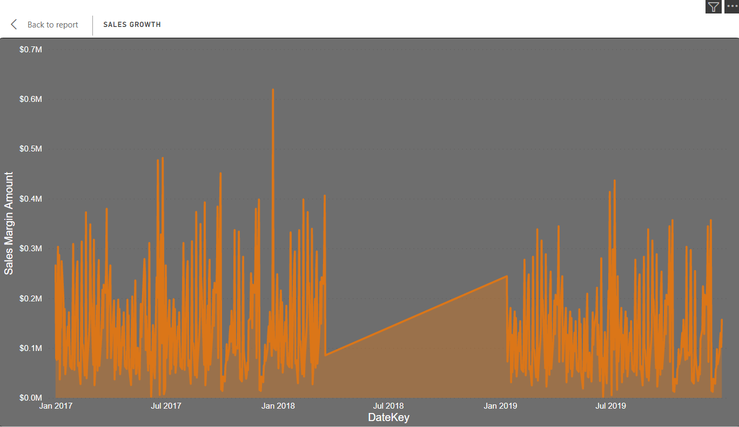

1. Dashboard 2 : Cost Amount and Discount

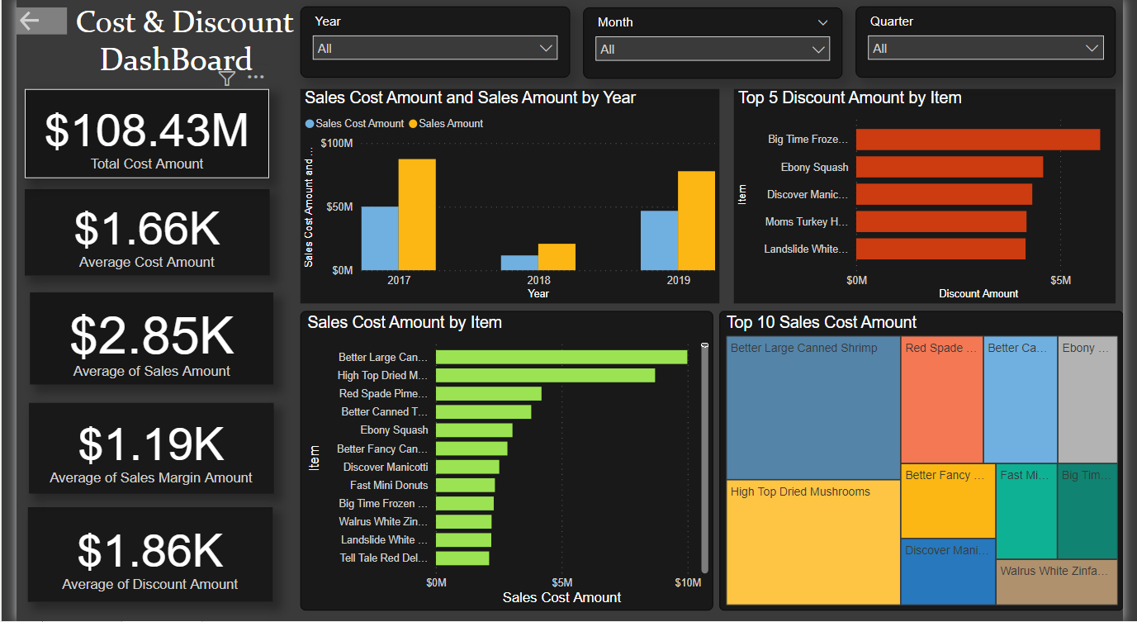

* Cost Amount and Sales Amount

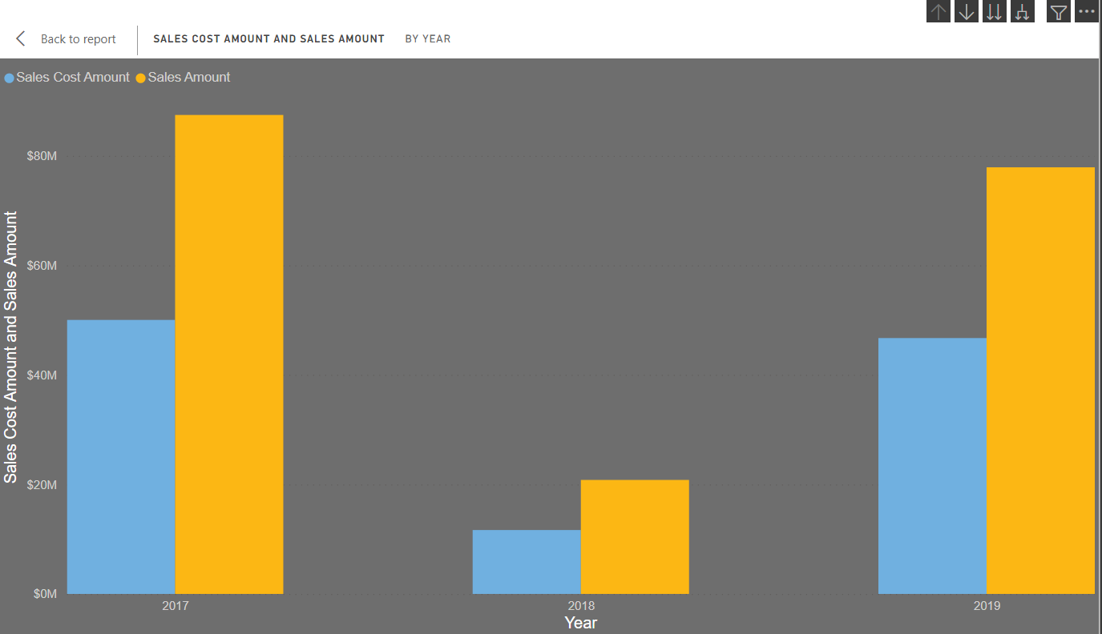

* Top 10 Sales Cost Amount

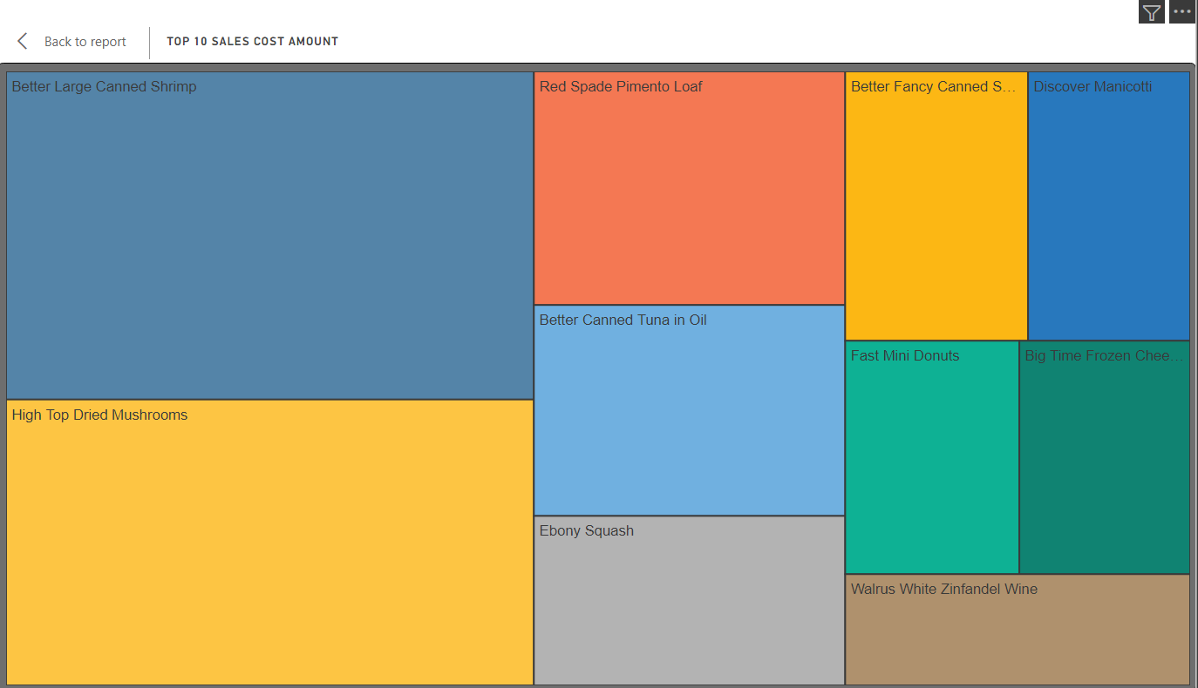

* Top 5 Discounted Item

